**Lab 2: Advanced Linux Commands**

**Name: Tejaswini Wanare Roll No.: 48 PRN no.: 12111129**

**------------------------------------------------**

**Problems to be solved**

**1. Change your password to a password you would like to use for the remainder of the**

**semester.**

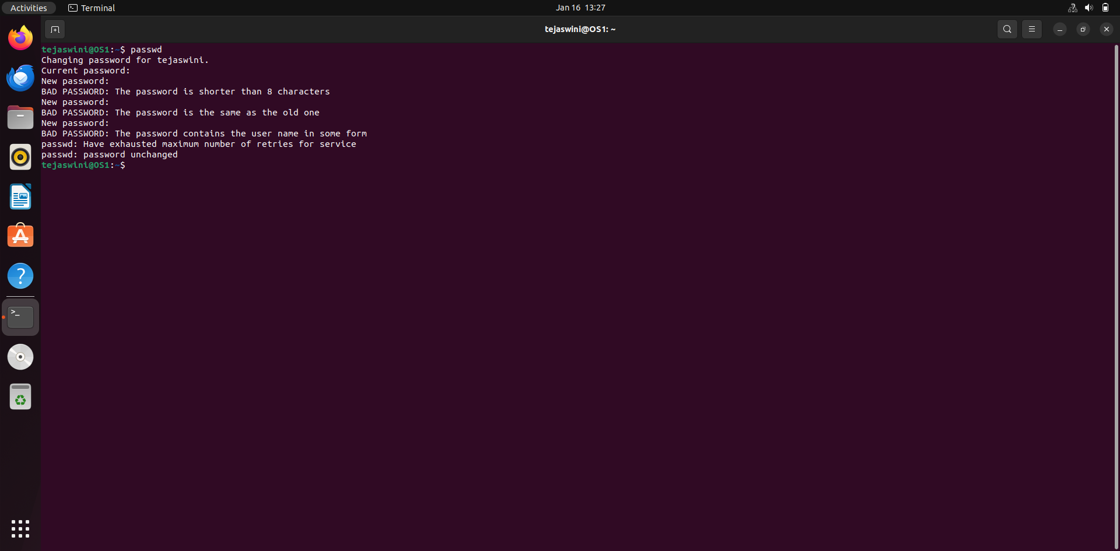

1. **Display the system’s date.**

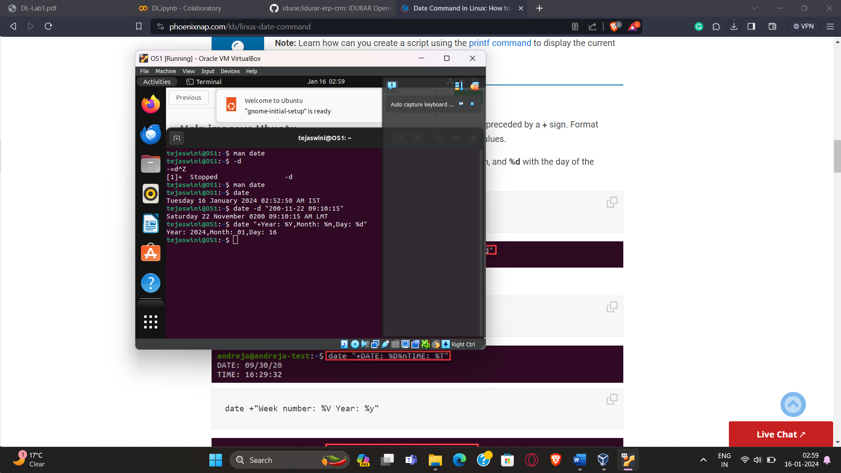

1. **Count the number of lines in the /etc/passwd file.**

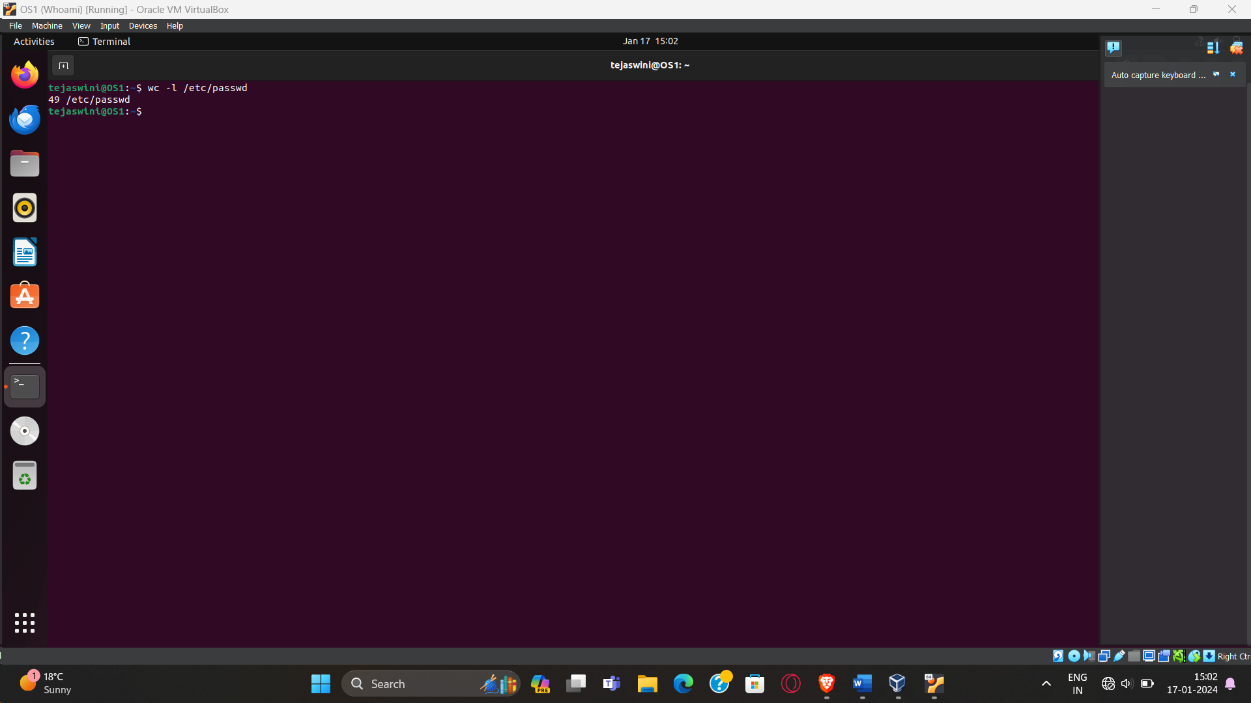

1. **Find out who else is on the system**

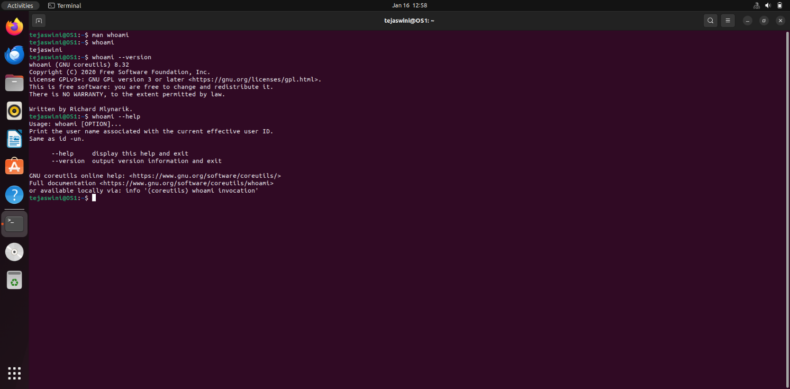

1. **Direct the output of the man pages for the date command to a file named mydate.**

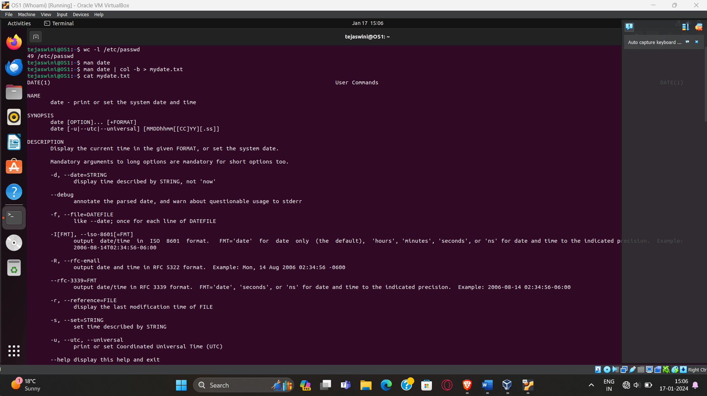

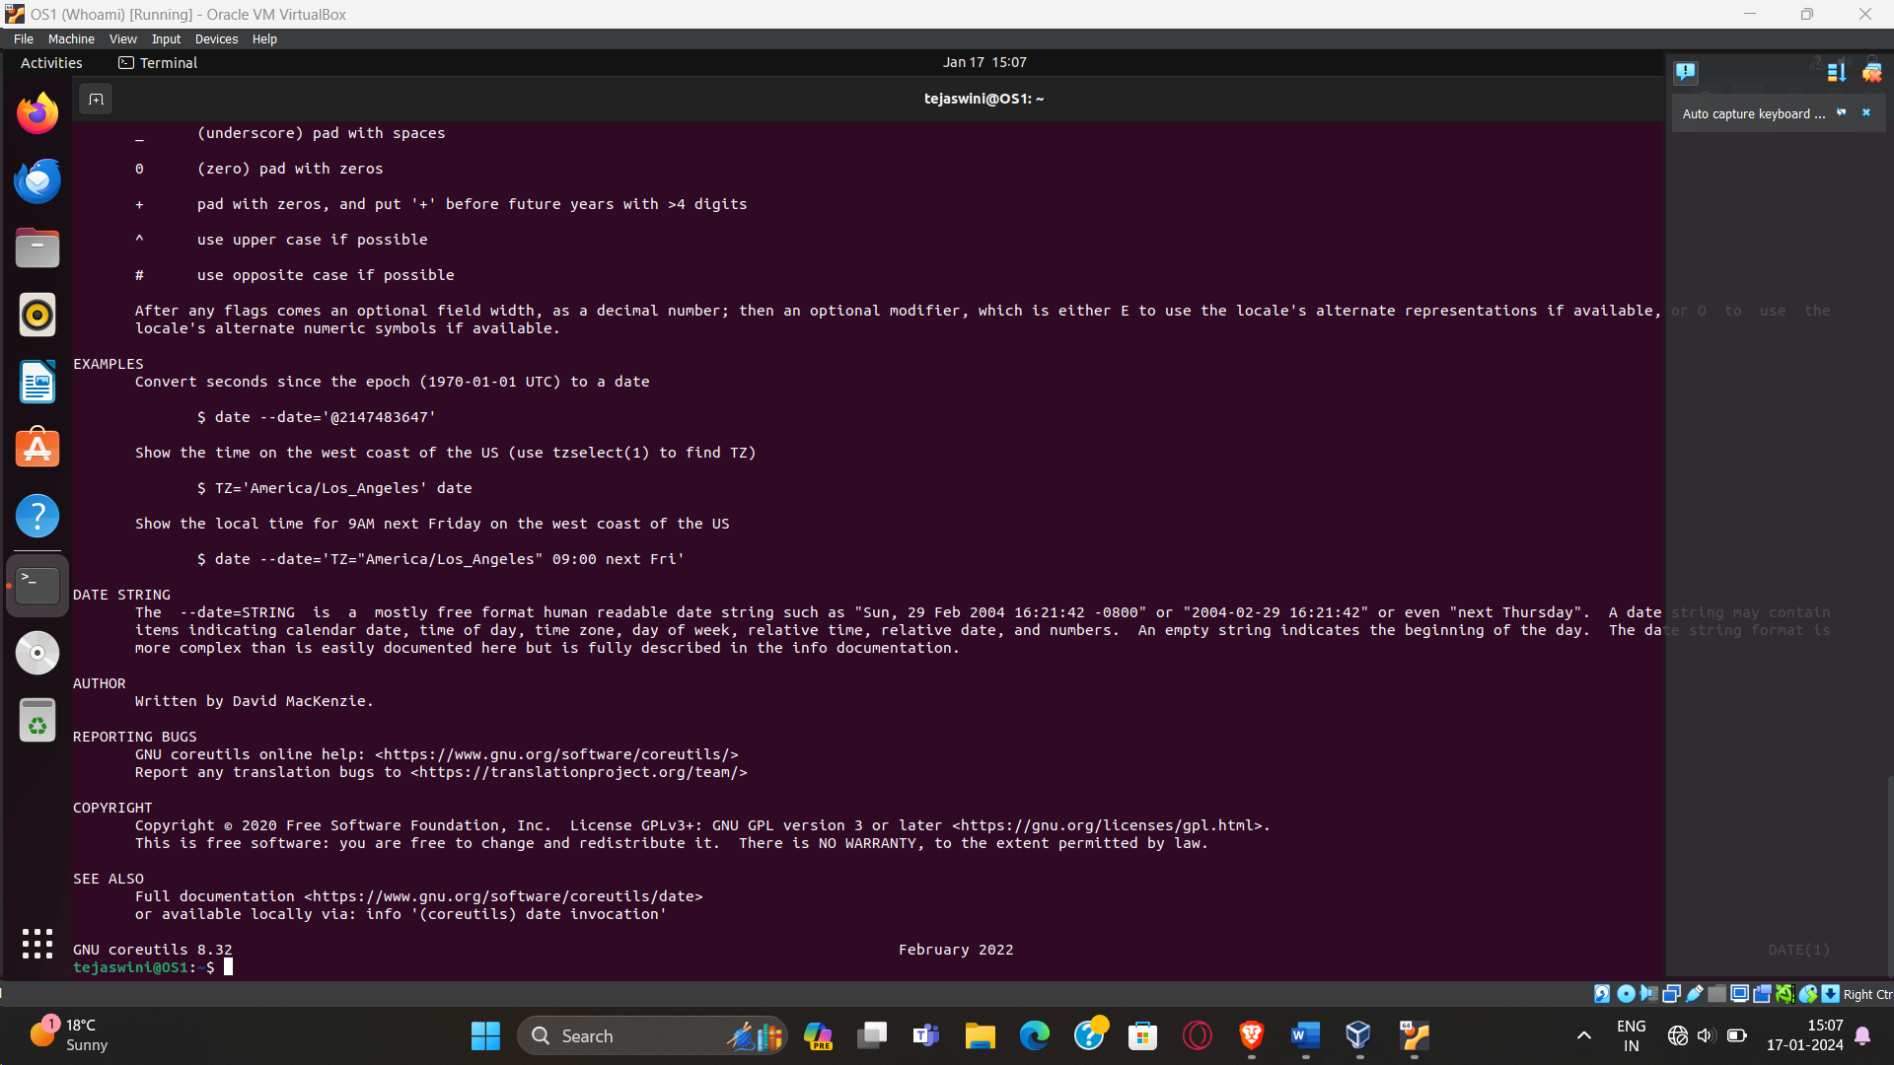

1. **Create a subdirectory called mydir.**

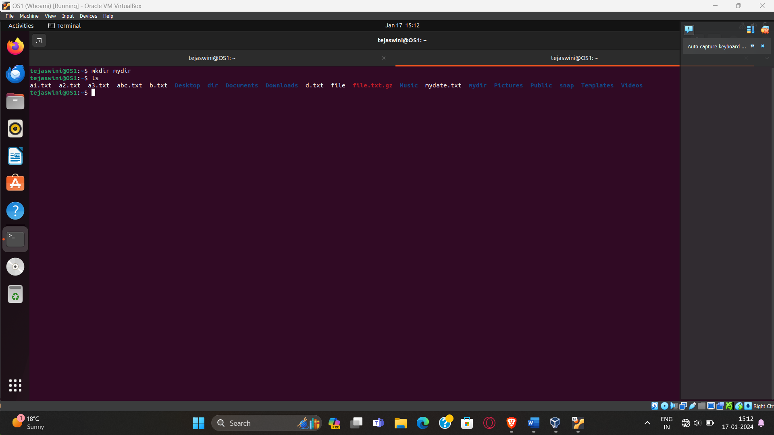

1. **Move the file mydate into the new subdirectory.**

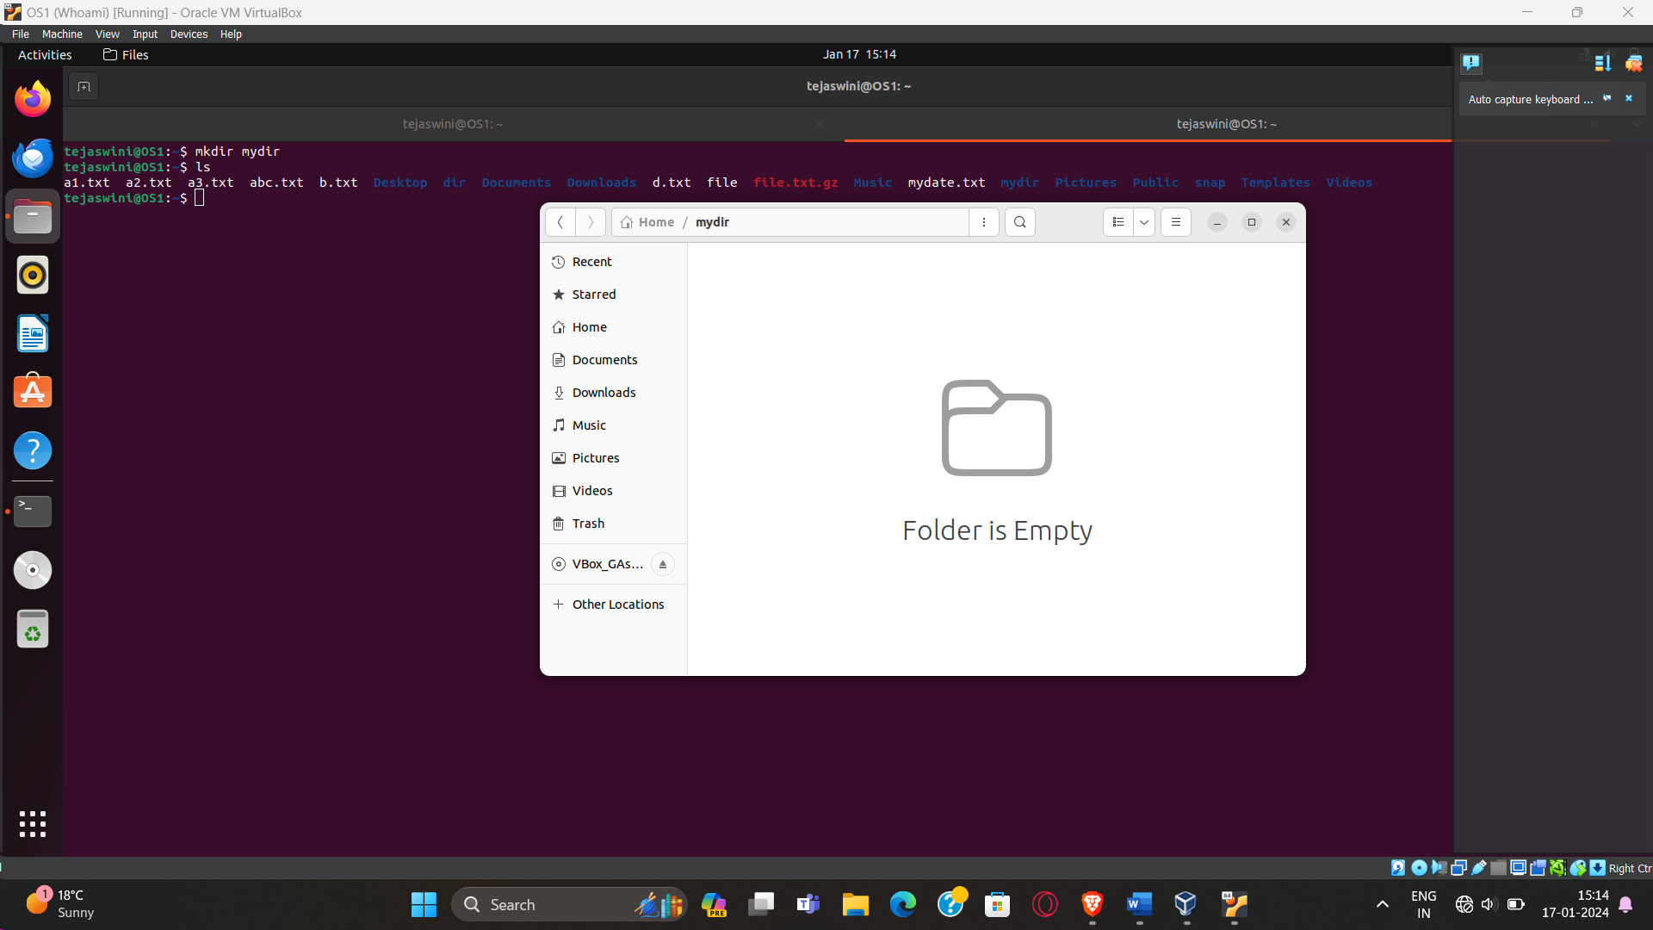

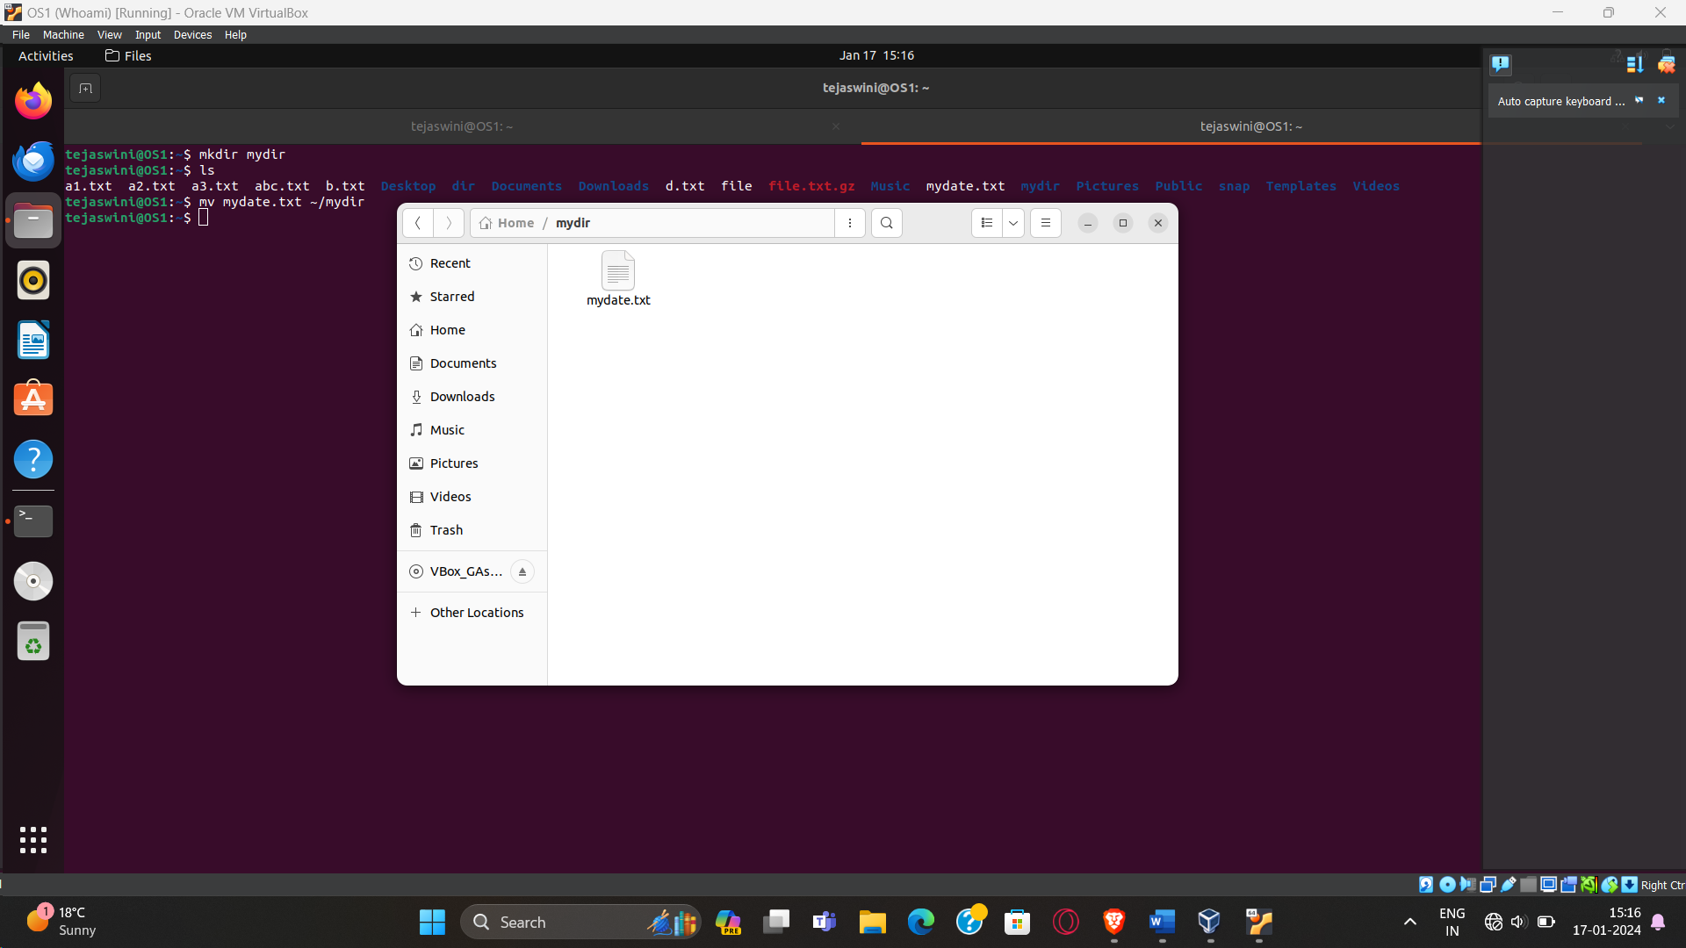

1. **Go to the subdirectory mydir and copy the file mydate to a new file called ourdate**

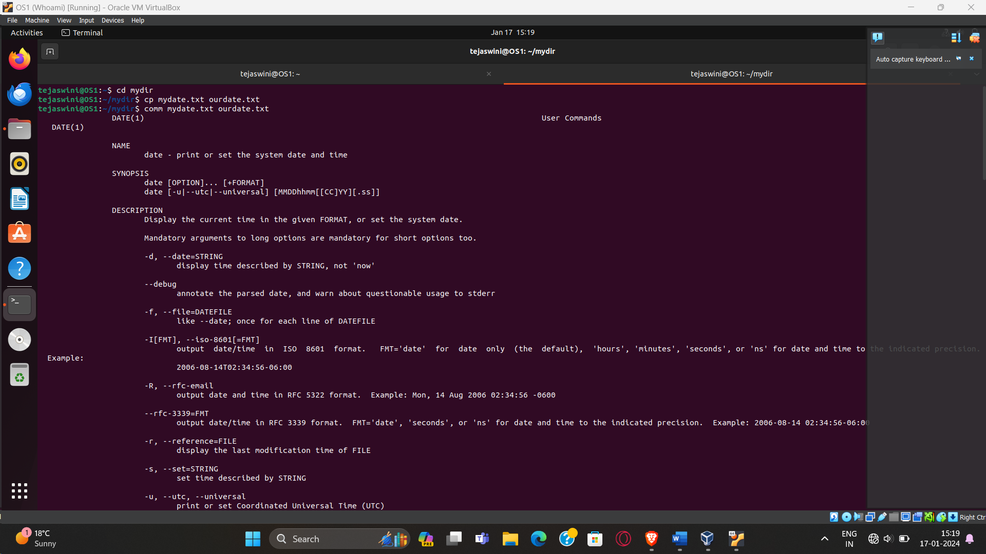

1. **List the contents of mydir.**

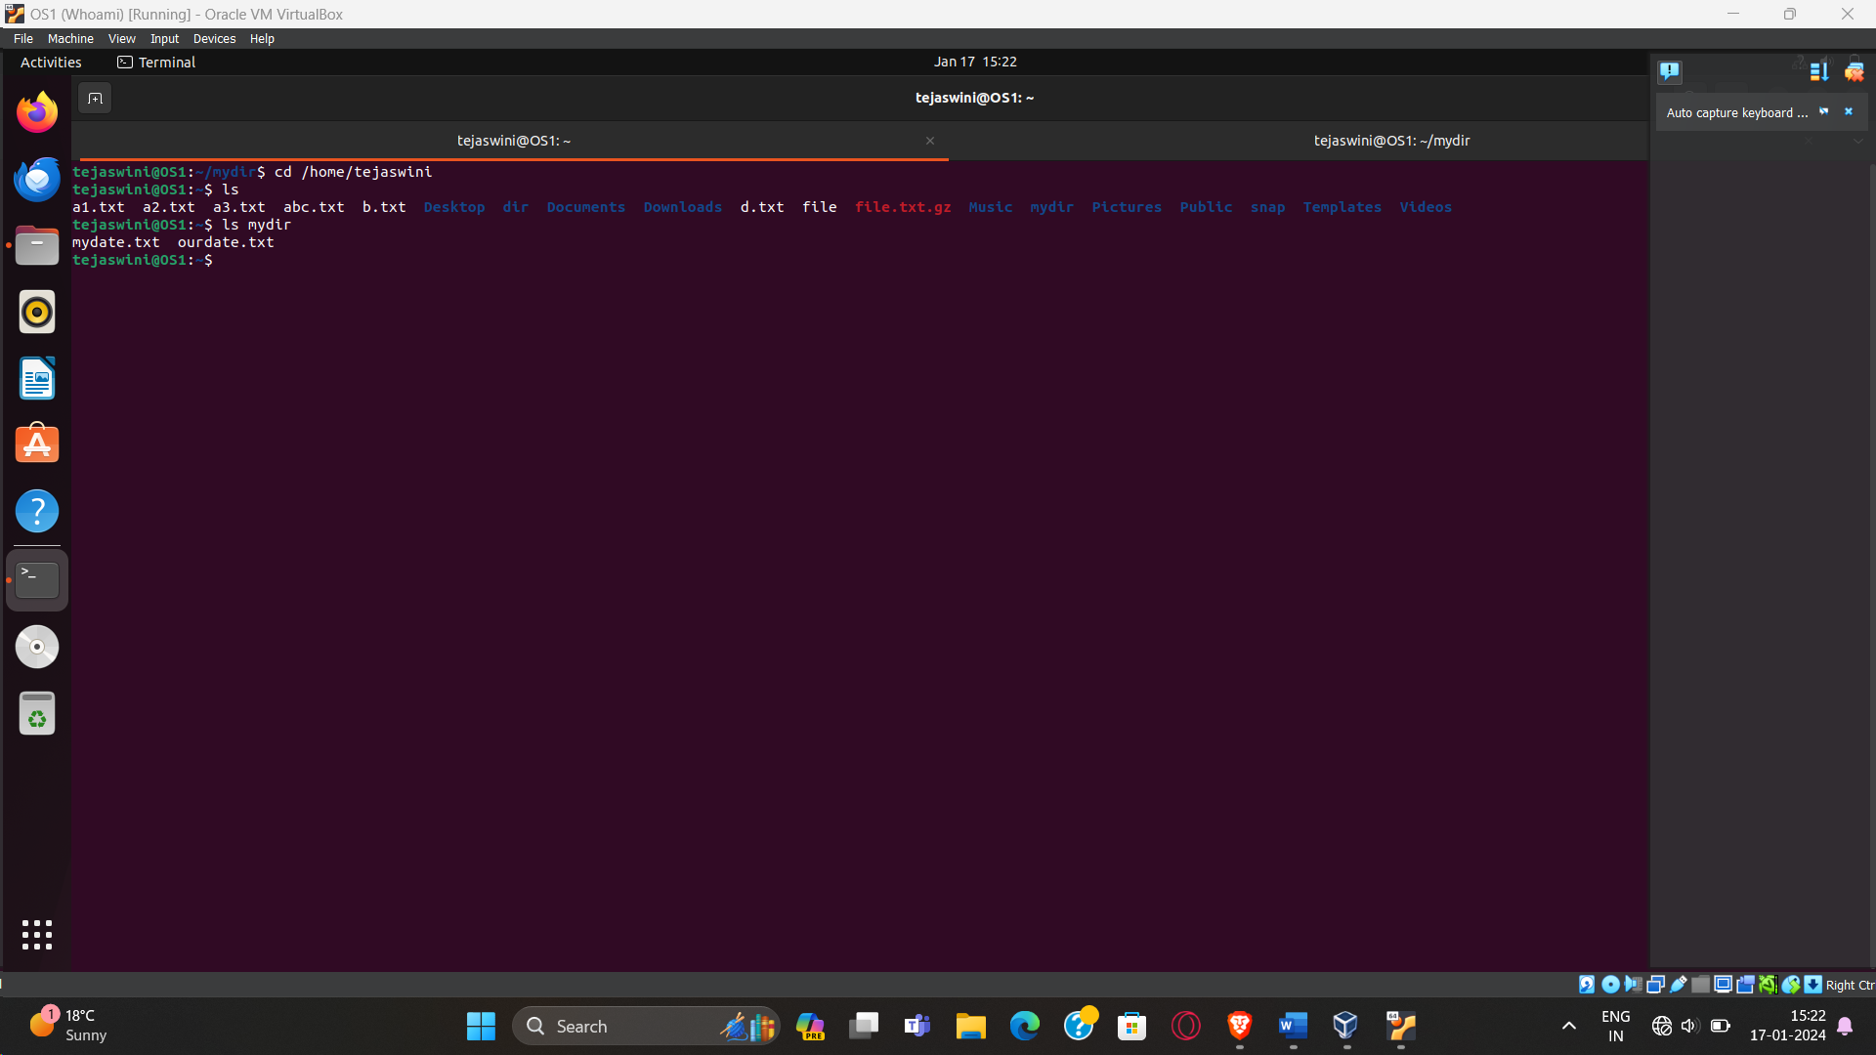

1. **Do a long listing on the file ourdate and note the permissions.**

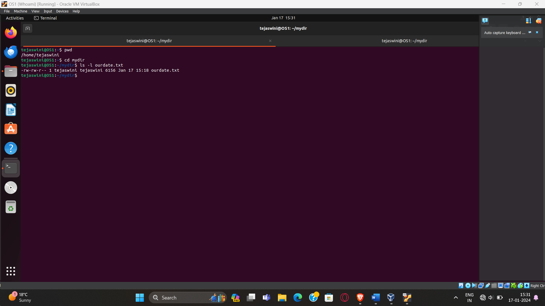

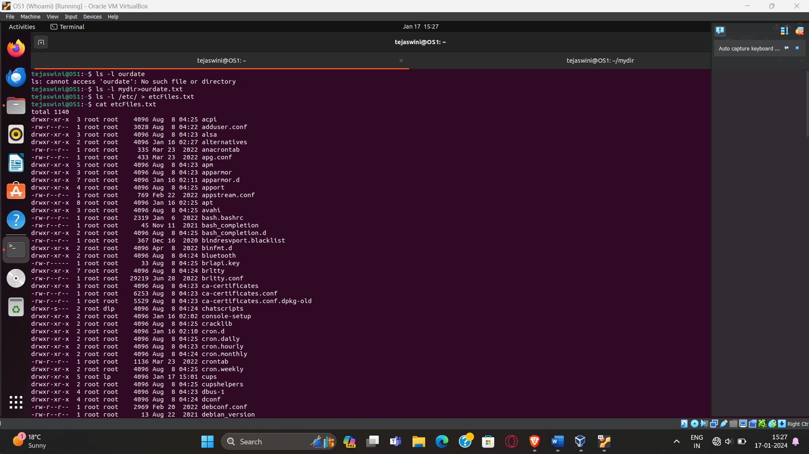

1. **Display the name of the current directory starting from the root.**

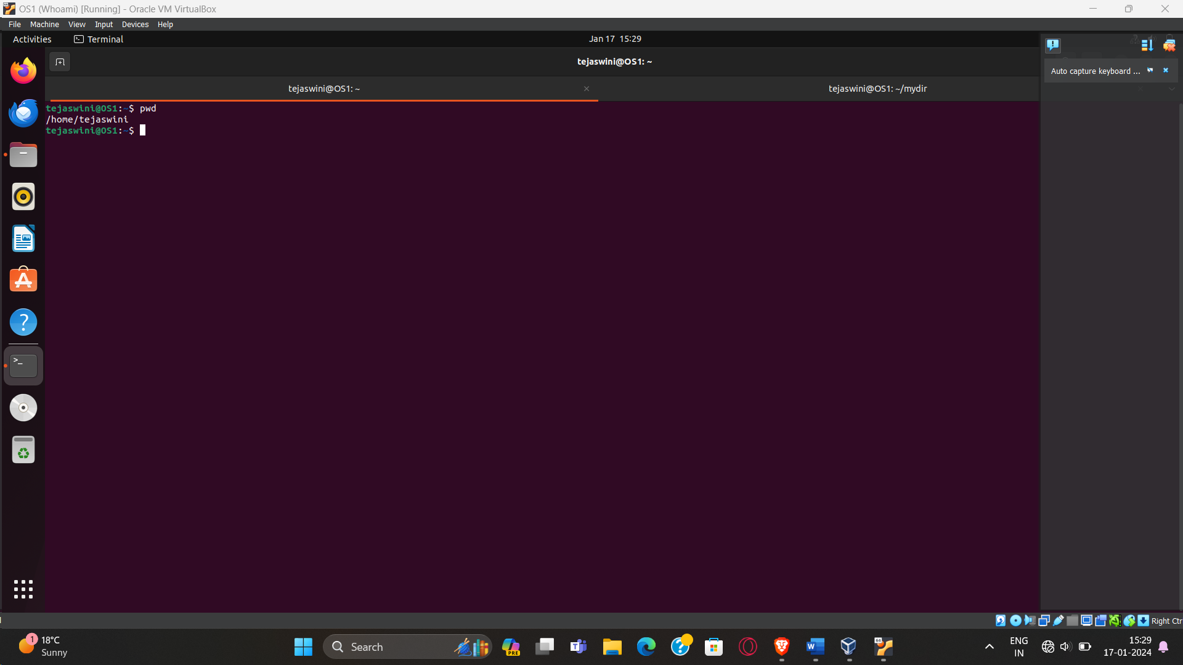

1. **Move the files in the directory mydir back to the HOME directory.**

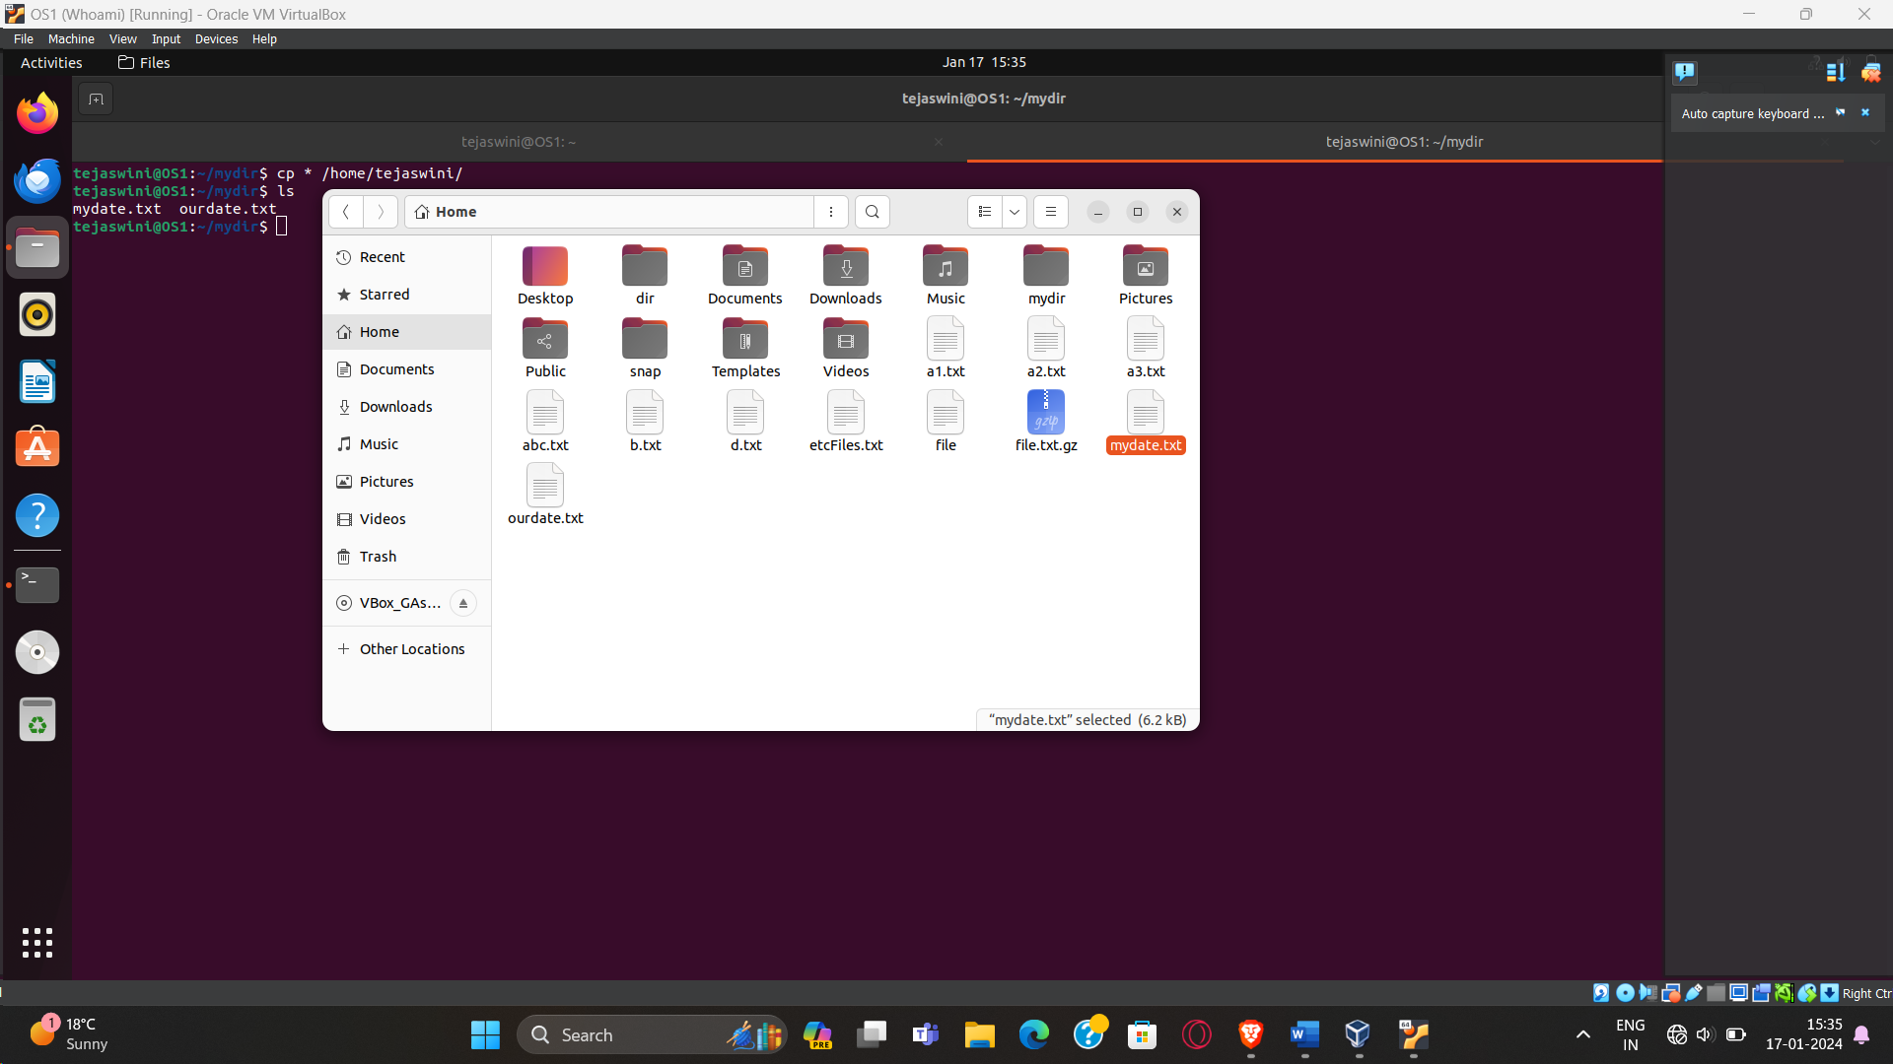

1. **List all the files in your HOME directory.**

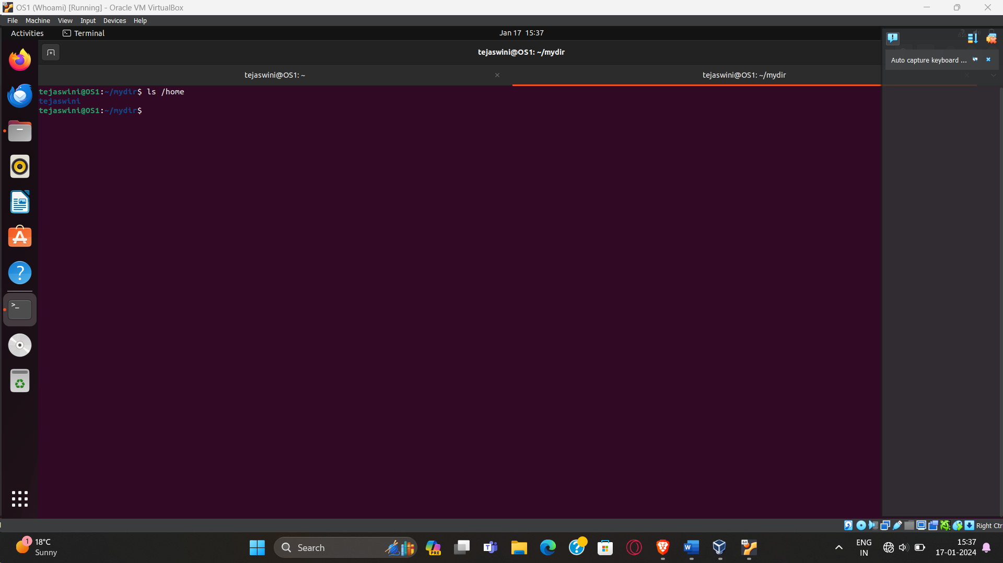

1. **Display the first 5 lines of mydate.**

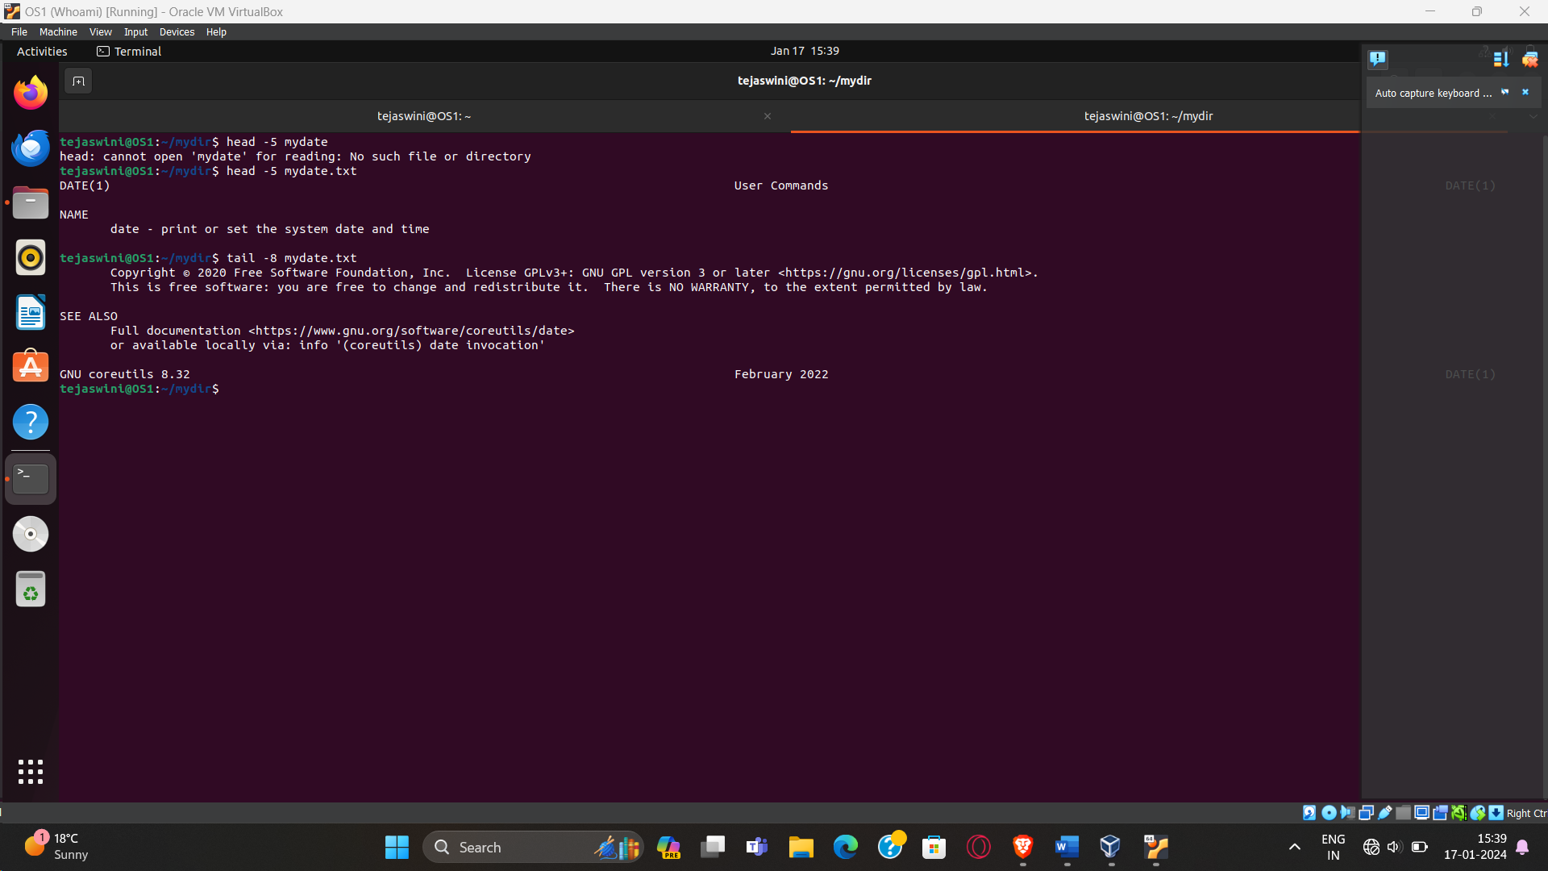

1. **Display the last 8 lines of mydate.**



1. **Remove the directory mydir.**

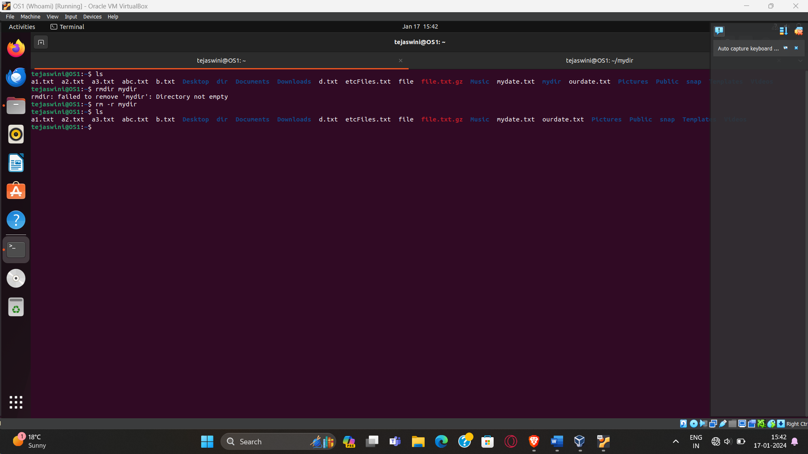

1. **Redirect the output of the long listing of files to a file named list.**



1. **Select any 5 capitals of states in India and enter them in a file named capitals1. Choose 5 more capitals and enter them in a file named capitals2. Choose 5 more capitals and enter them in a file named capitals3. Concatenate all 3 files and redirect the output to a file named capitals.**

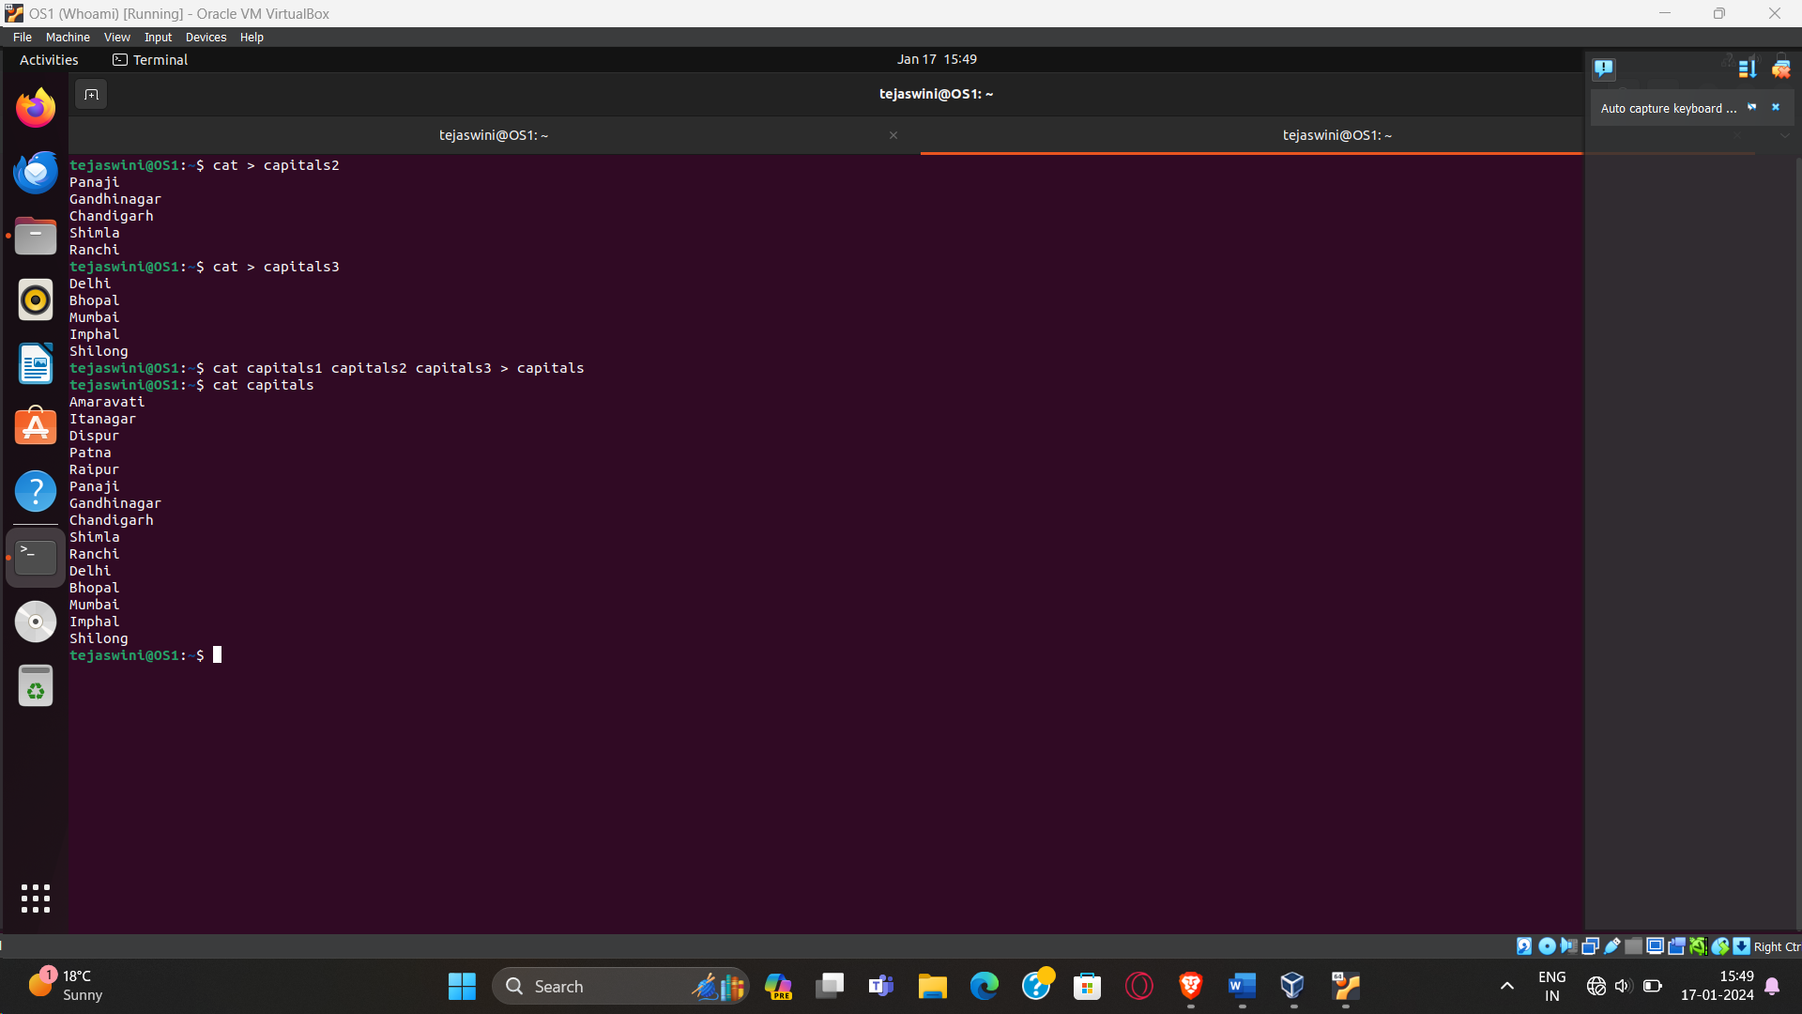

1. **Concatenate the file capitals2 at the end of file capitals.**

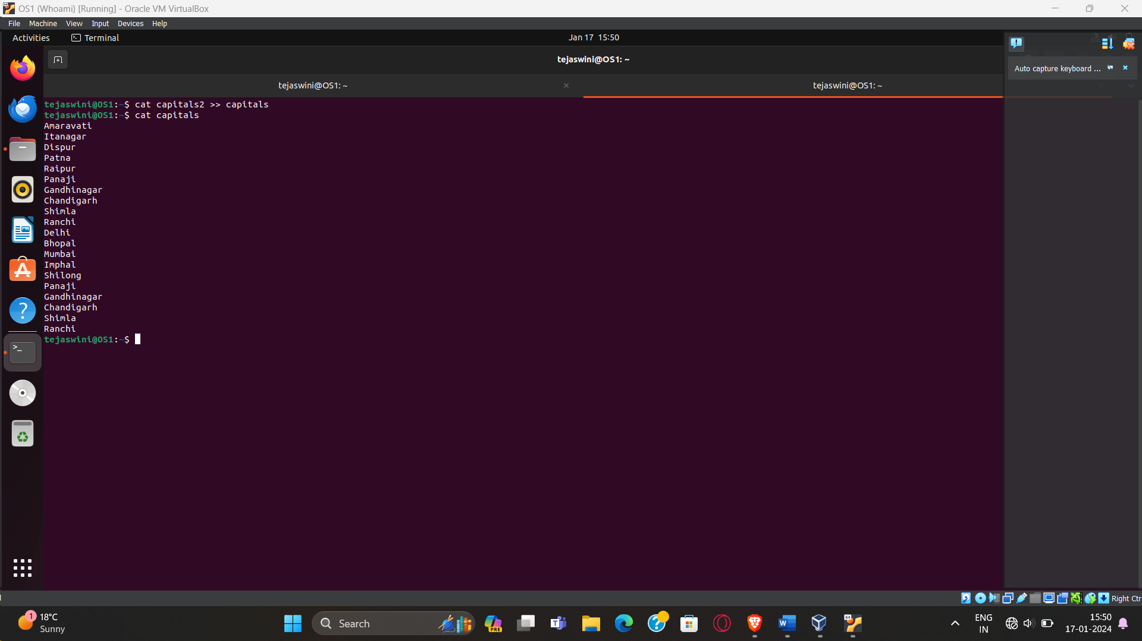

1. **Redirect the file capitals as an input to the command “wc –l”.**

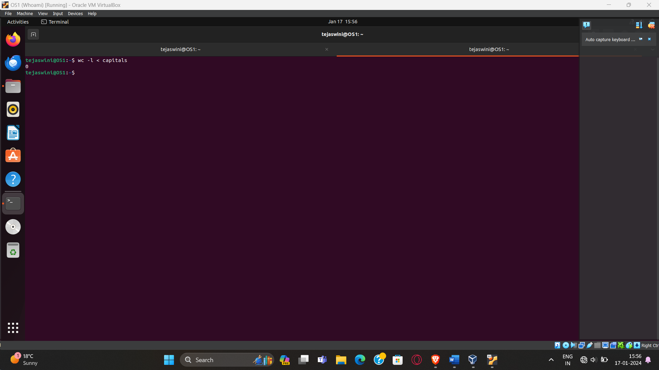

1. **Give read and write permissions to all users for the file capitals.**

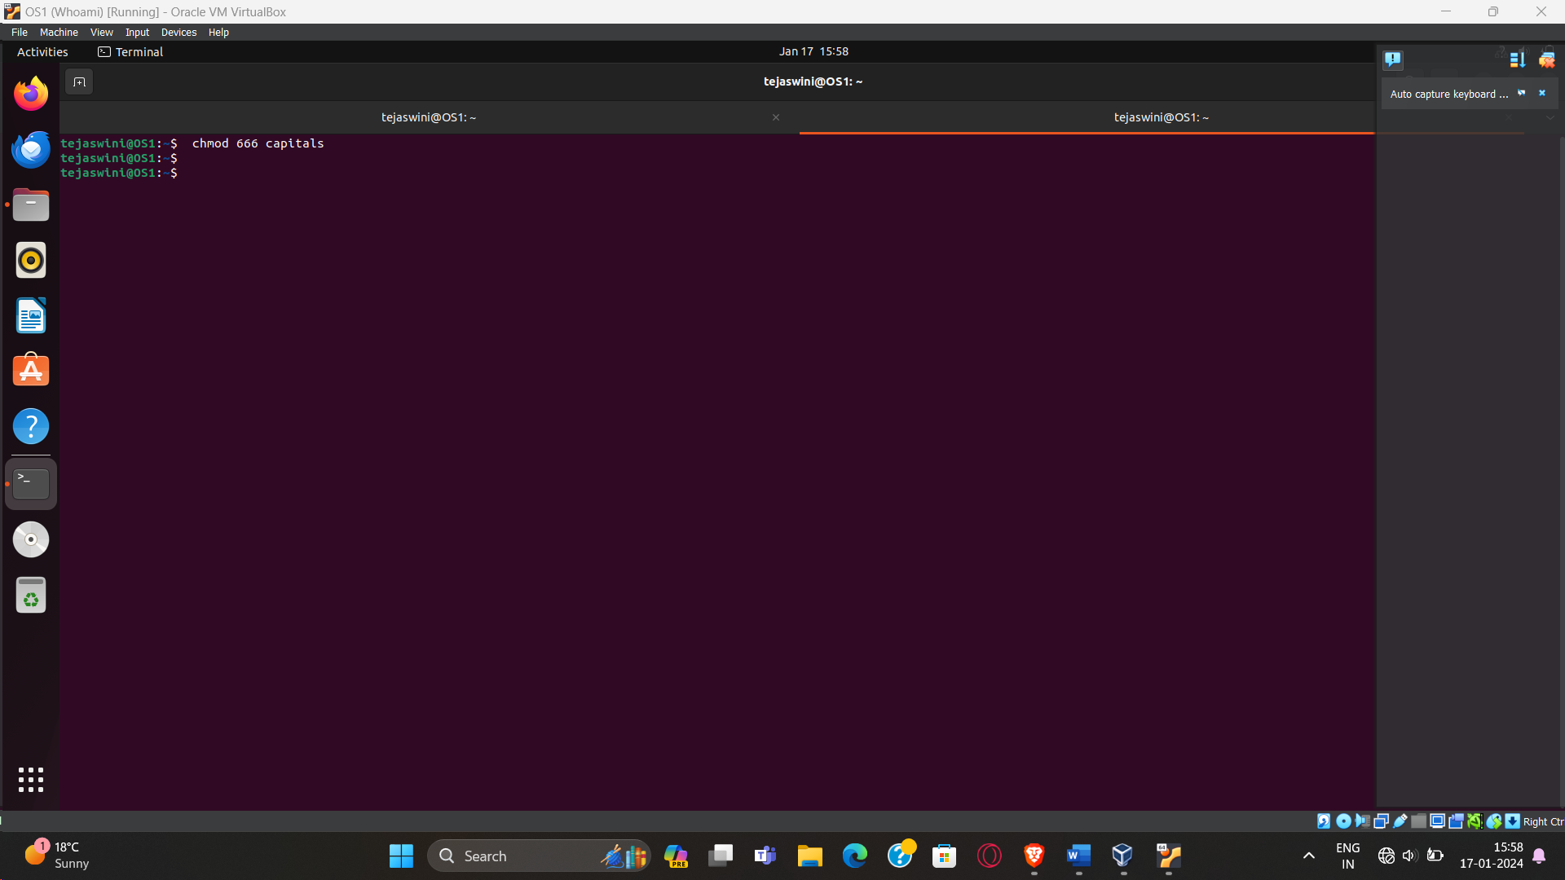

**22. Give read permissions only to the owner of the file capitals. Open the file, make some**

**changes and try to save it. What happens ?**

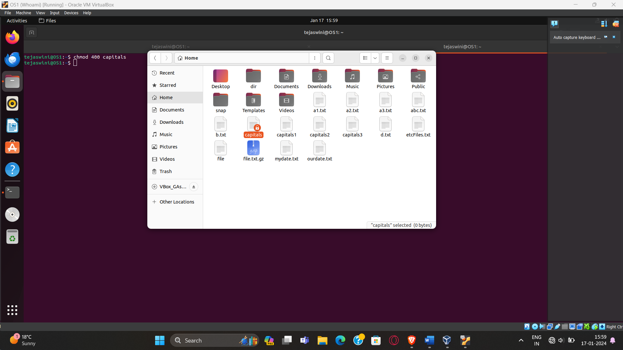

**23. Create an alias to concatenate the 3 files capitals1, capitals2, capitals3 and redirect the output to a file named capitals. Activate the alias and make it run.**

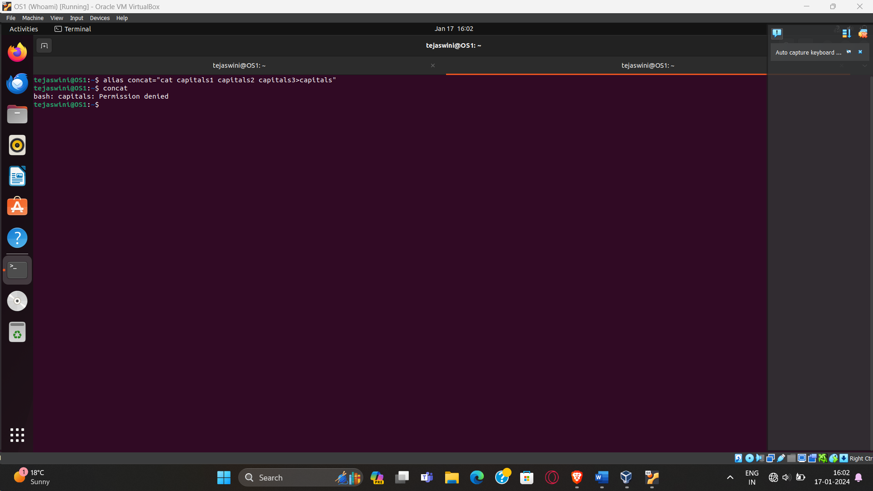

**24. What are the environment variables PATH, HOME and TERM set to on your terminal ?**

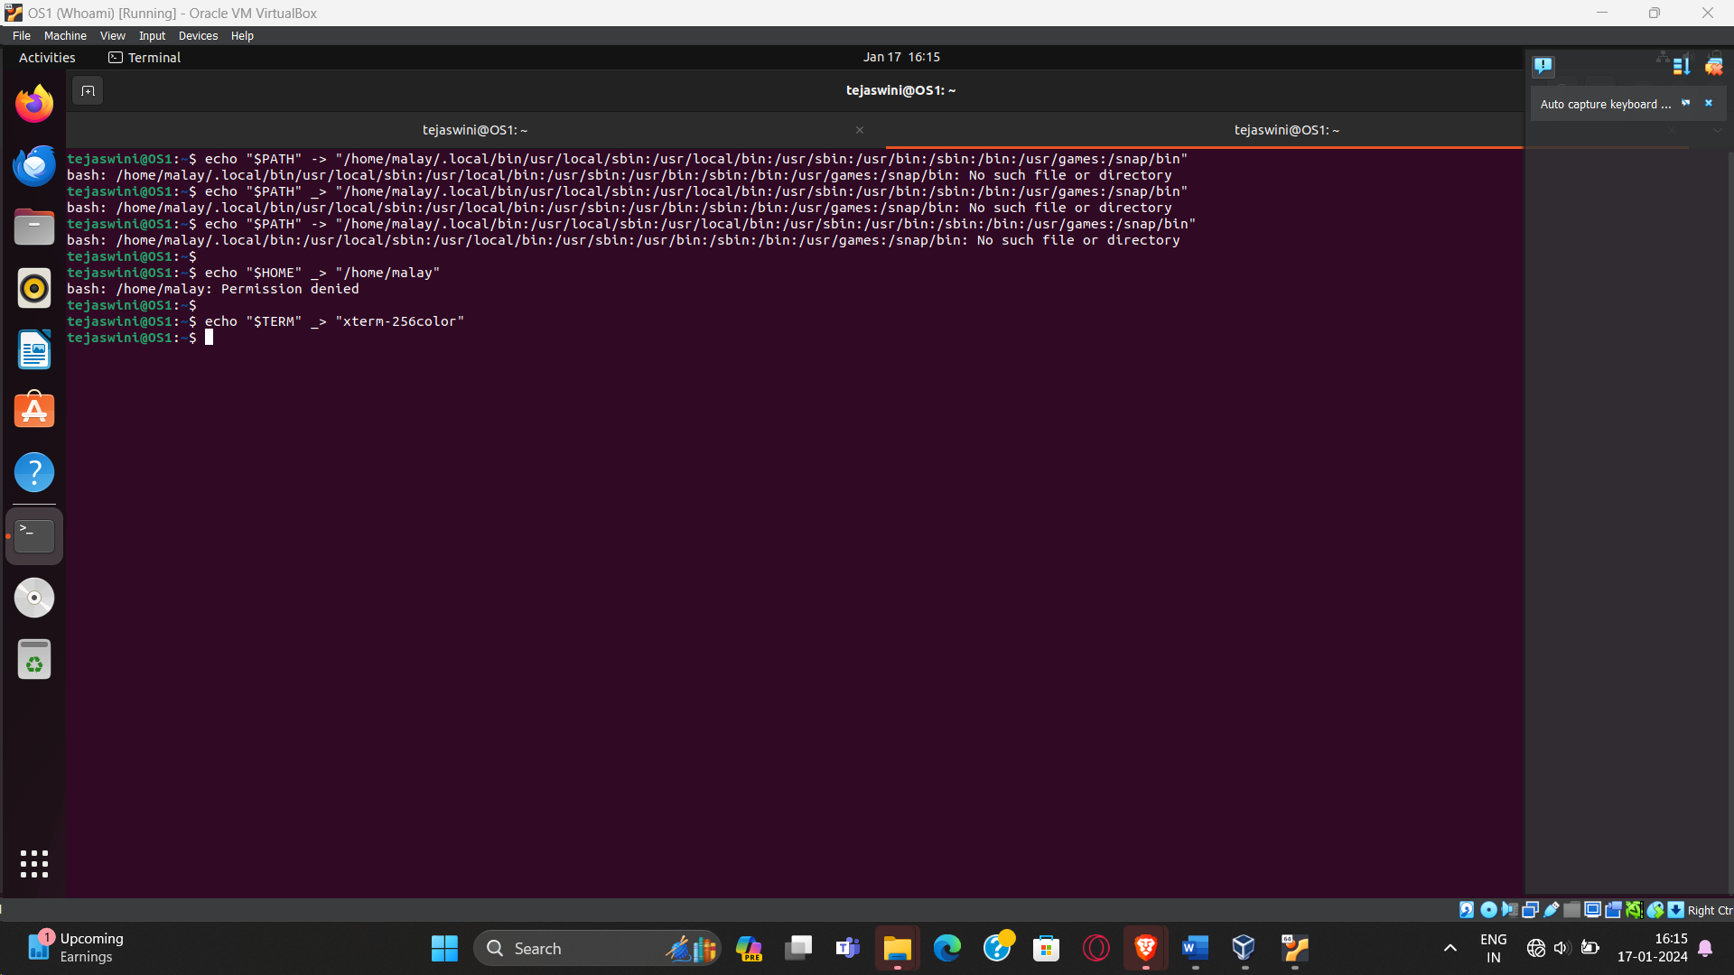

**25. Find out the number of times the string “the” appears in the file mydate.**

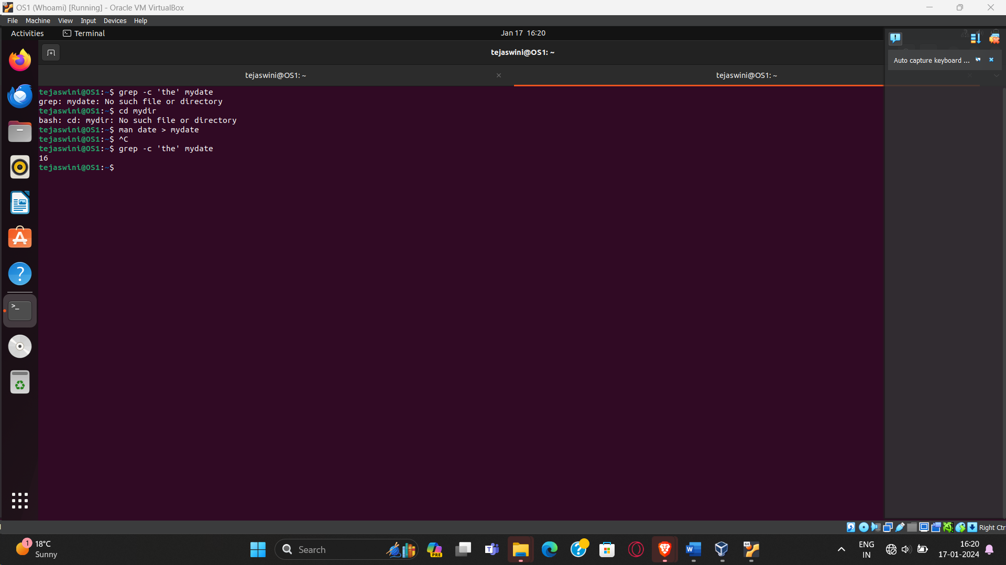

**26. Find out the line numbers on which the string “date” exists in mydate.**

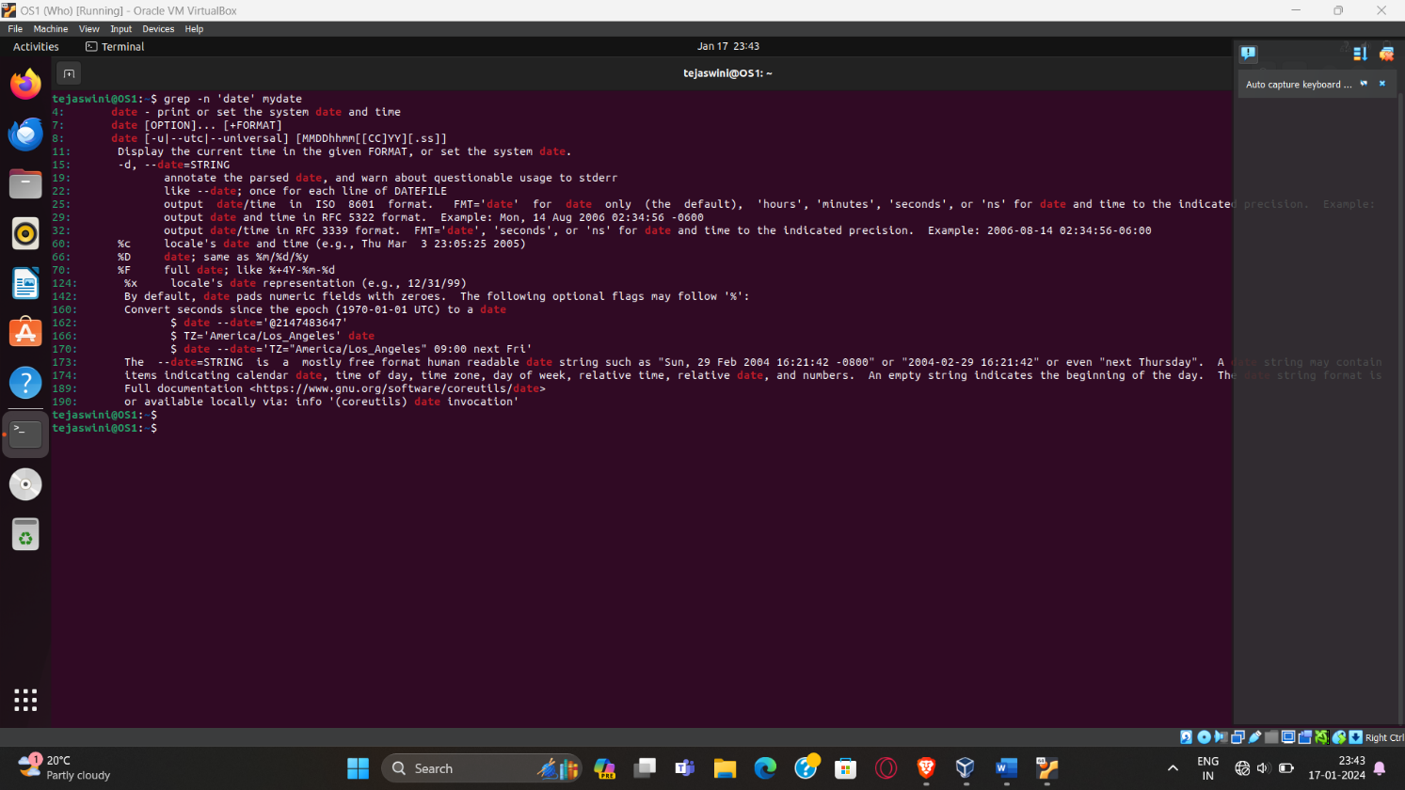

**27. Print all lines of mydate except those that have the letter “i” in them.**

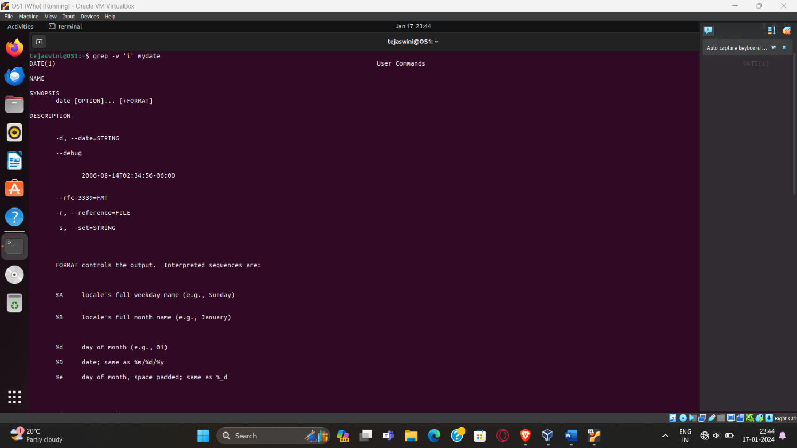

**28. Create the file monotonic as follows:**

**^a?b?b?c? .................x?y?z$**

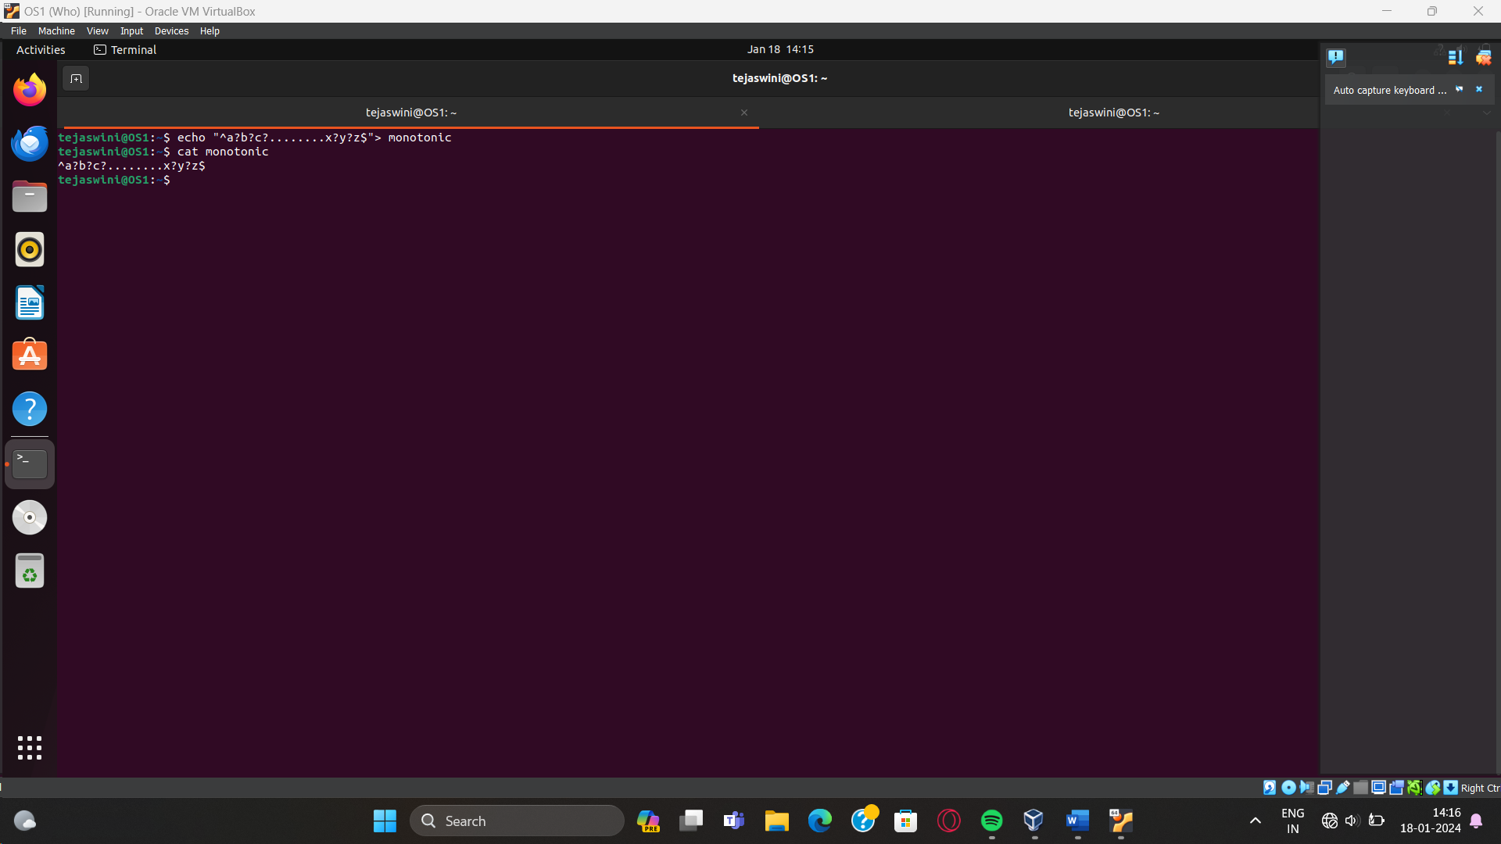

**29. List 5 states in north east India in a file mystates. List their corresponding capitals in a file mycapitals. Use the paste command to join the 2 files.**

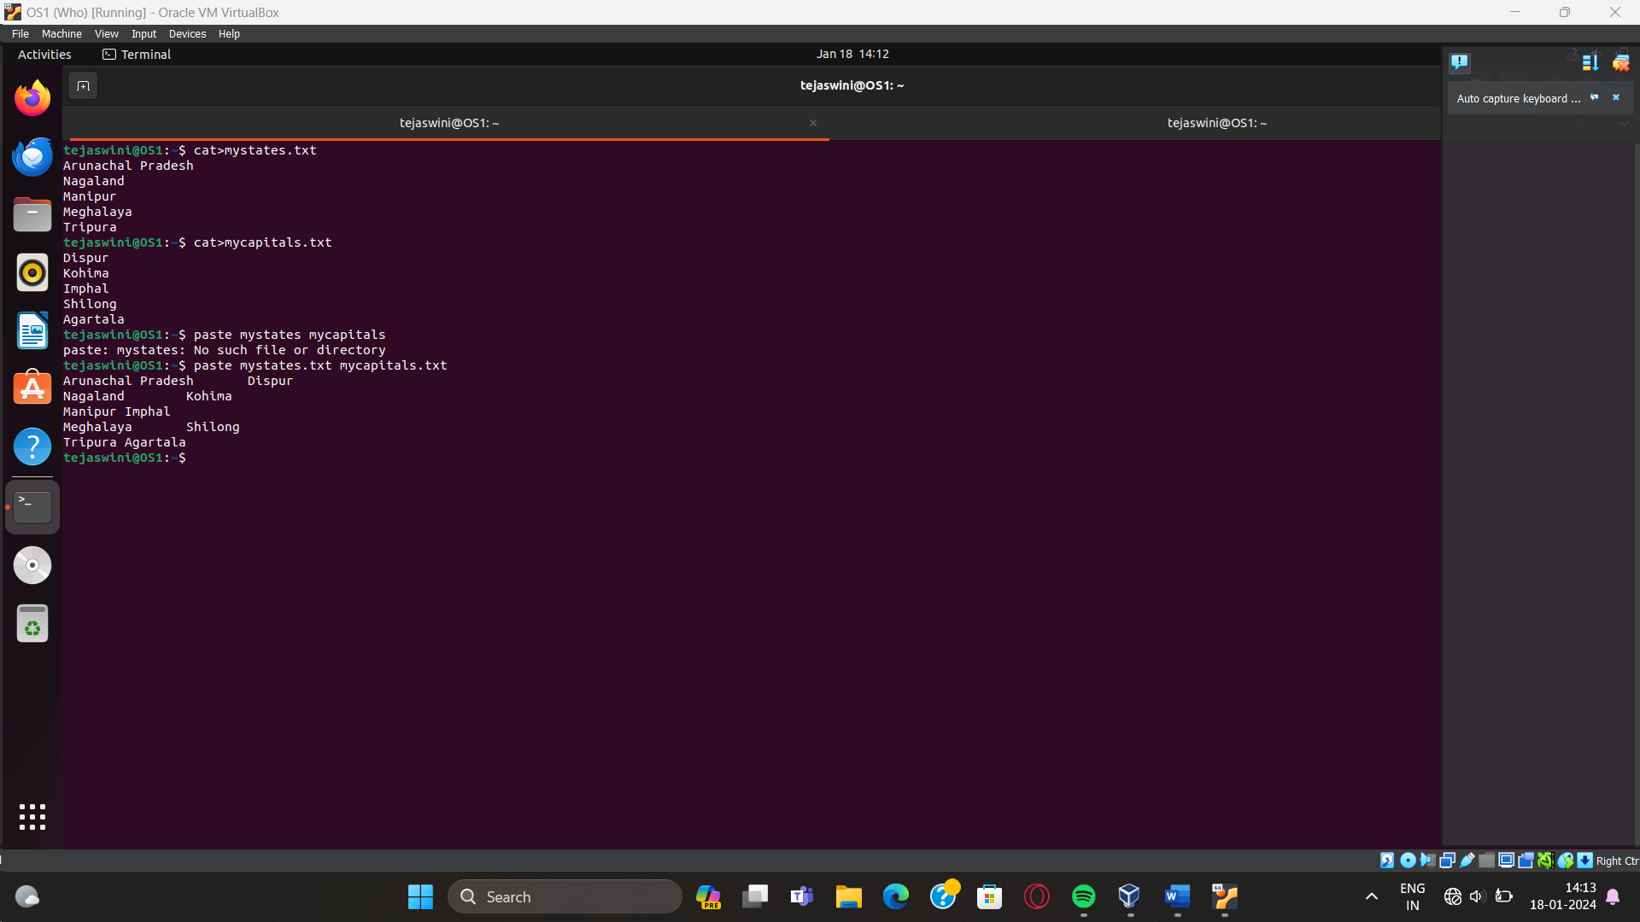

**30. Use the cut command to print the 1st and 3rd columns of the /etc/passwd file for all**

**students in this class.**

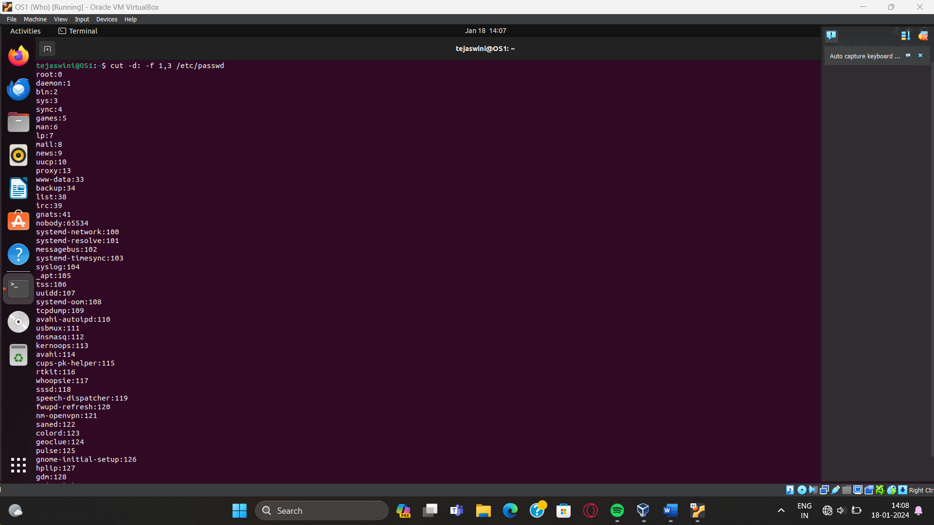

**31. Find**

**the number of people logged in and also trap the users in a file using the tee**

**command.**

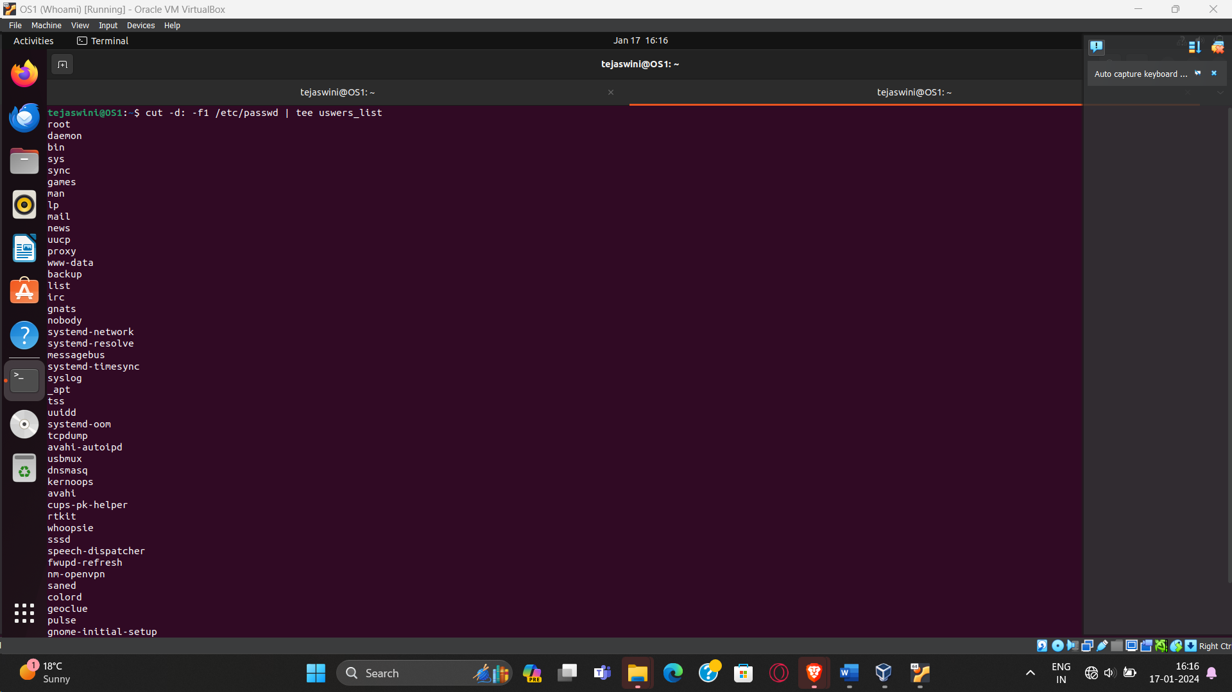

172.20.0.